**Project for the Degree of B.Sc. Engineering**

**Client –Server Network**

**Md. Monir Ahammod**

**Student ID: 16CSE061**

**Department of Computer Science and Engineering**

# Bangabandhu Sheikh Mujibur Rahman Science and Technology

**University, Gopalganj, Bangladesh**

**January,2019**

**By**

**Md. Monir Ahammod**

**Student ID: 16CSE061**

**Supervised by**

# F.M.Rahat Hasan Robi

**Project Evaluation Committee:**

**Teacher Name 1** *..................................*

**Teacher Name 2** *.................................*

**Teacher Name 3** *..................................* nothing

**Project Approval**

Student’s Name: Md. Monir Ahammod

Student’s ID:16CSE061

Project Title: :Client- Server Network

We the undersigned, recommend that the project completed by the student listed above, in partial fulfillment of B.Sc. Engineering degree requirements, be accepted by the Department of Computer Science and Engineering, Bangabandhu Sheikh Mujibur Rahman Science and Technology for deposit.

**Supervisor Approval\***

.............................

Name of Supervisor: F.M.Rahat Hasan Robi

Designation of Supervisor: Lecturer

**Additional Approvals ( if requires)\***

.............................

Name of Supervisor: Md. Akkas Ali

Designation of Supervisor: Asst.Professor &Chairman

**Departmental Approval**

.............................

Name of Head of the Department: Md. Akkas Ali

Chairman, Department of Computer Science and Engineering

## Bangabandhu Sheikh Mujibur Rahman Science and Technology

**University, Gopalganj.ineering**

# Abstract

Client-server architecture, architecture of a computer network in which many client (remote processors) request and receive service from a centralized servers (host computers). Client computers provide an interface to allow a computer user to request services of the server and to display the results the server returns. A client computer can perform many tasks, such as services on the devices as listed (dhcp, dns, mail, web, ftp).Keywords**:** Ip addressing ,DHCP,HTTP, DNS,FTP ,Mail,Server.

# Acknowledgment

I am very much thankful to the almighty Allah for giving me the opportunity to complete the project successfully. Then I am also thankful to my supervisor, F.M.Rahat Hasan Robi for allowing my idea of this project. For his supervision,I have been able to do such project.

I would like to express my heartfelt thanks to all of my friends for inspiring and supporting me to make the project success.

Md.Monir Ahammod, January,2019

# Table of Contents

**Abstract i**

**Acknowledgment ii**

**Chapter 1 Introduction 1**

**Chapter 2 Related Works 2**

**Chapter 3 Implementation Details 3**

**Chapter 4 Result 4**

**Chapter 5 Limitations and Future Work 7**

**Chapter 6 Conclusion 8**

**List of figure**

|  |  |
| --- | --- |
| 4.1 Design & Connected networks . . . . . . . . . . . . . . . . . . . . . . . . . . . . . . . . | 4 |
| 4.2 Ip Configuration . . . . . . . . . . . . . . . . . . . . . . . . . . | 4 |
| 4.3 Dhcp & Dns server . . . . . . . . . . . . . . . . . . . . . . . . . . . . . . . . | 5 |
| 4.4 Mail server . . . . . . . . . . . . . . . . . . . . . . . . . . . . . . . . | 5 |
| 4.5 Admin Webside . . . . . . . . . . . . . . . . . . . . . . . . . . . . . . . . | 6 |
| 4.6 FTP server . . . . . . . . . . . . . . . . . . . . . . . . . . . . | 6 |

# Introduction

Information and communication are two of the most important strategic issues for the success of every enterprise , organization or public sources. Computer networks allow the user to access remote programs and remote databases either of the same organization or from other enterprises or public sources, prior to that time there were computer vendor networking designed primarily to connect terminals and remote job entry stations to a mainframe ; But the notion of networking between computers viewing each other as equal peers to achieve resource sharing was fundamental to the apernet design.

# Related Works

This paper describes a new line of enquiry on which we are embarking at Oxford Brookes University. The general motivation for the work is to explore whether Active Networks offer solutions to the scalability issues which beset conventional approaches to the construction of Large-

 The researchers developed a client-server based application called OpTel Billing System (OBS) using Java NetBeans and TCP datagram to demonstrate the concepts of socket programming and its communication in a distributed computing. Interface design, socket programming style, java classes, and exceptions are also considered in the development stage

# Implementation Details

I have used basic Networking theory. 1. Physically connect all of the devices(computers) with appropriate cables, 2. Configure IP addressing on all of the networking devices (follow the device labels) 3. Configure the server services on the devices as listed (dhcp, dns, mail, web, ftp) 4. Test your server services using the client computers. The tools are required to develop the program are given below :

* Cisco packet traser.
* HTML
* CSS
* Java

## Chapter 4

# Result

Figure 4.1 : Design & Connected networks

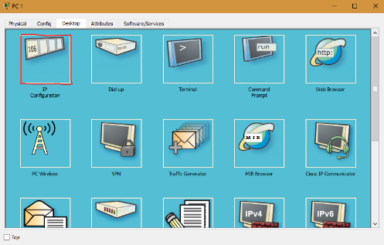 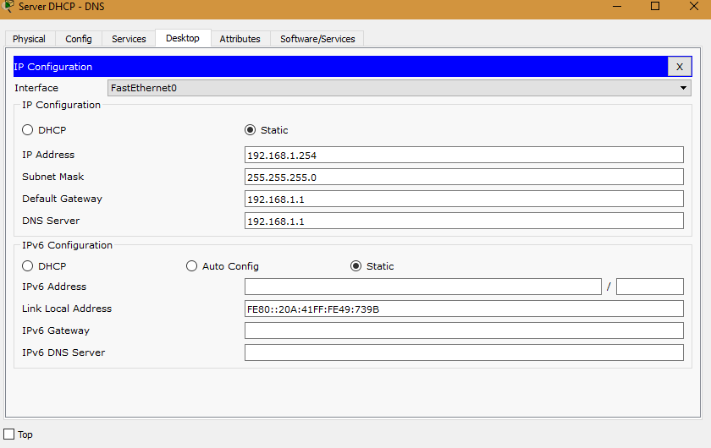

Figure 4.2 : Ip Configuration

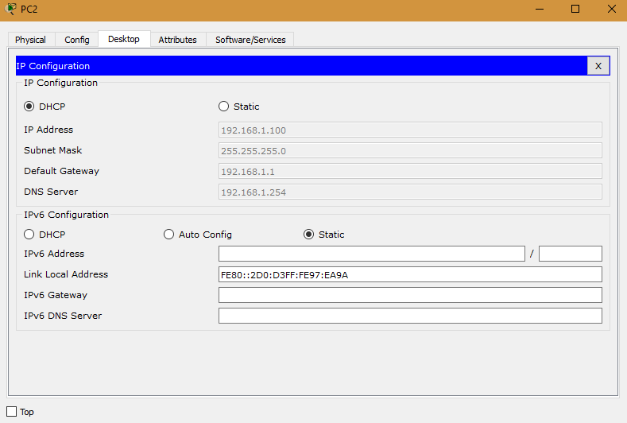 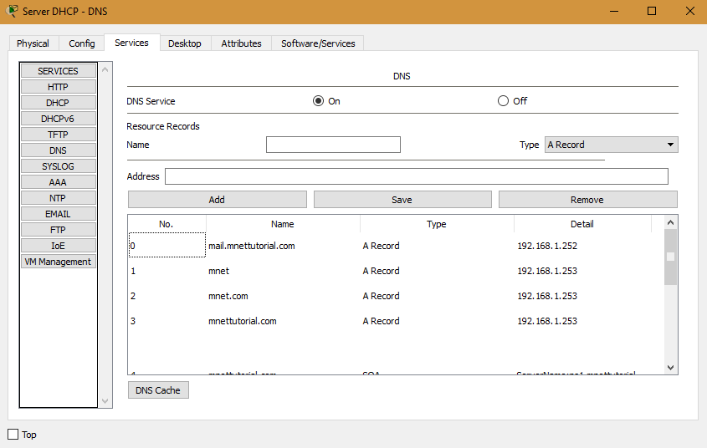

Figure 4.3 : Dhcp & Dns server

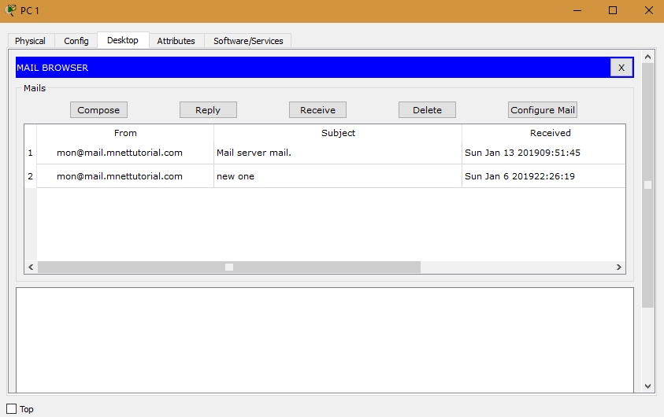

Figure 4.4 : Mail server

5

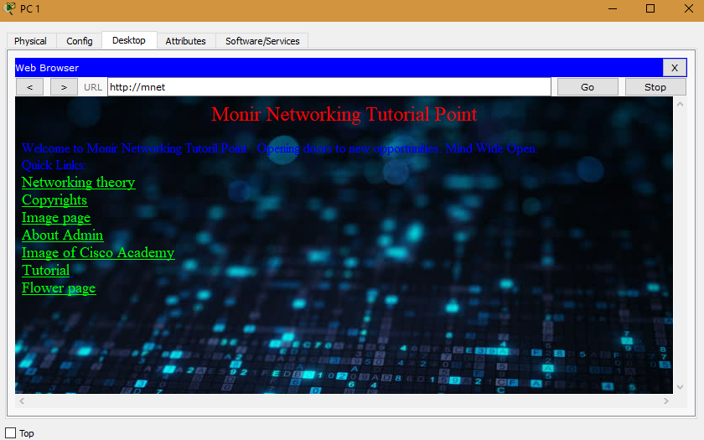

Figure 4.5 : Admin Webside

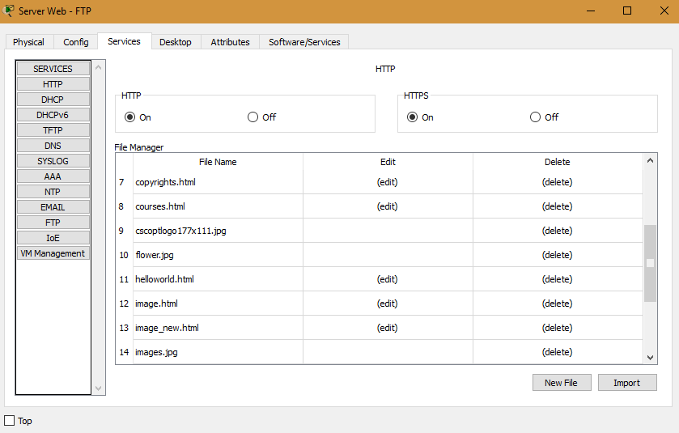

Figure 4.6 : FTP server

6

## Chapter 5

# Limitations and Future Work

Many clients can access the server’s information download and upload at the same time, a client computer can perform other tasks, such as sending mail ,Web browser. There are many limitation in this section .Today are facing internet speed problem. Then we are facing internet security problem,all the problem are releted to network client server base. I have also faced limitation to demonstate this project .This is a private network. But in toadys public is very important .So in future I will work with this topic .

In future I will make a thesis paper related to this topic. In this time network based project is palying important role making this world more easier to easier.

By publishing any thesis paper I will try to solve the limitation of this project.

7

## Chapter 6

# Conclusion

Information and communication are two of the most important strategic issues for the success of every enterprise , organization or public sources. Computer networks allow the user to access remote programs and remote databases either of the same organization or from other enterprises or public sources.

Information in this era is very important because every second we are communicating with each other .Networking is also plays an important role in this manner .

If we think about our daily life we cannot think our daily occurances without internet or networking.

8